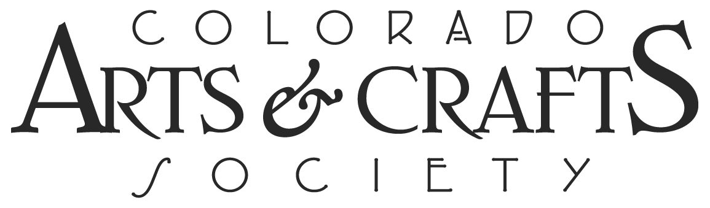

2019 “GATHERING OF THE GUILDS” VENDOR CONFIRMATION

Date & Time: Sunday, April 14, 2019 from 10 AM–4 PM (Setup from 8-10 AM; Breakdown from 4-6 PM)
New Location: American Mountaineering Center, 710 10th Street, Golden, CO 80401 (303) 996-2786

Thank you for participating in this year’s Guild Forum. Kindly return this completed form by 3/2/19 to Cynthia Shaw at cshaw@jeffco.us. Call 720-497-7632 with questions.

Note: We will notify you in advance of your assigned location inside AMC. While Wifi is available, manual credit card transactions are encouraged. Breakfast & Lunch items will not be available onsite but can be brought in and/or purchased in downtown Golden.

Guild/Artisan/Antique Dealer name:

Your participants’ names:

Space size you’d prefer: We can’t guarantee your first request, but number them by priority. Please list any special space requirements you may have below.
6x8 ft. space against a wall or in center of room
5 x 10 ft. space against a wall or in center of room
8x8 ft. space in center of room
10x10 ft. space against a wall

Tables: We have a limited number of tables, but we can provide you with one of the following. Please bring other tables if you need them (chairs will be provided):
Round 5’ (20 available)
Rectangular 6’ x 1.5’ (18 available)
Rectangular 6’ x 3’ (4 available)
Rectangular 8’ x 2.5’ (1 available)

Ongoing demonstrations (describe):

Formal presentations, talks or workshops (scheduled for 11 AM, 1 PM, 2 PM & 3PM):
Title (30-45 minutes total followed by Q&A) | Time Preferred

Special needs for space, presentation, workshops, etc.:

Confirmed by (please sign and include your email address, phone number and mailing address):

